__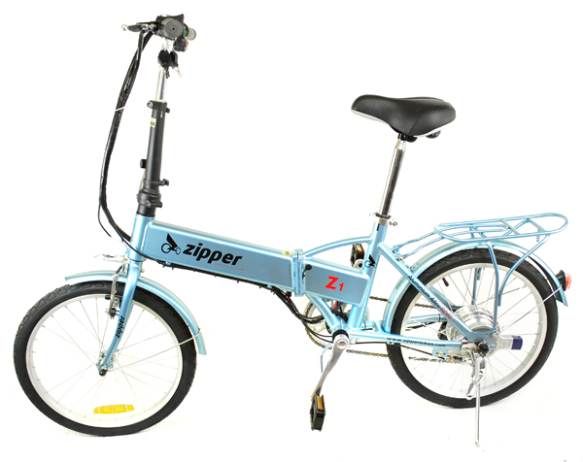
Thank you for purchasing the Zipper Z1 Power Assisted Electric Bicycle (EPAC). The Zipper Z1 features the most recent innovation in technology and applies to the ISO 4210-2 standard. Your new Zipper e-bike is made with a strong aluminium alloy frame, making it light yet durable, and comes with a lithium battery pre-installed, which has a range of up to 40km on a single charge. The Z1 was designed for inner city commuting, built with comfort and style in mind.
The electric motor in your bike will assist you when pedalling to make cycling easier. You can adjust the level of assistance using the assistance level switch on the handlebars with level 1 giving minimal assistance and level 3 giving maximum assistance. The motor will only assist up to a maximum speed of 15.5MPH. The bike may also be used like a normal bike without any assistance from the motor.

Note: We cannot guarantee the performance of our couriers. If you receive a Zipper e-bike which was damaged in transit, please take a picture before assembly and send it to our email address support@zipperbikes.com before use and we’ll send the replacement part.

Contents Table
Specifications | Page 3
Important Safety Information | Page 4
Riding Safety | Page 5
eBike Safety | Page 6
Braking Safety | Page 6
Electrical Safety | Page 6
Charging Procedure | Page 7
Battery Safety | Page 8
Mechanical Parts Safety | Page 8
Folding Lock Mechanism | Page 9
Rear Wheel Lock | Page 9
Brakes Instructions & Adjustment | Page 10
Front Wheel Installation | Page 11
Inflating The Tyres | Page 11
Installing The Handlebars | Page 11
Seat Setup | Page 12
Adjusting The Chain | Page 12
Attaching The Pedals | Page 12
Attaching The Mudguard | Page 13
Adjusting & Operating The Gears | Page 13
Light Operation | Page 13
Cleaning | Page 13
Maintenance | Page 13
Maintenance Schedule | Page 14
Troubleshooting | Page 15
Specifications Specifications Specifications

Specifications
Brand | Zipper | Model | Z1
Bike Specification
Tyre Size | 20 inch | Weight |  | 20kg
Size | 1550×180×1030 | Folding Size |  | 800×300×580
Length×Width×Height  （mm） |  | Length×Width×Height  （mm）
Front And Rear Tyre Centre Distance（mm） | 1045 | Frame |  | Aluminum Alloy
Max Load | 90kg | Max Peed |  | 25km/h
Motor Specification
Motor Type | Brushless | Motor | 36V250W
Rated Speed | 280 RPM | Rated Output Speed | 7.5 N.m
Controller Specification
Cut-Off Voltage | 30+1V | Burst Discharge Current | 13+1A
Charger Specification
Input Voltage | AC110-240V 0.8A 50-60HZ
Charging Voltage And Current | DC42.0V 2A
Battery & PAS Range
Battery | Model | Pas Range | Operating Tem
36V 9AH | PAS | 30-40km | -10℃~+50℃

Important Safety Information
The term “eBike” throughout this manual refers to your Electrically Power Assisted Cycle (EPAC).
As with all bicycles, a Zipper eBike must be used and maintained properly in order to function correctly. Please read this manual carefully before use as it contains vital safety information to ensure the continued performance of the bike and for safety reasons. Improper handling can pose danger to your safety and health. If you have any queries, please feel free to contact our customer service department.
Before Using Your Bike
- Please charge the battery and pump the tyres before usage!
- Please observe national laws and local travel regulations, violations of which are not the responsibility of Zipper Bikes.
- Our products are constantly being updated and changed therefore specifications may change slightly from those listed in this manual.
- Please operate your bike according to the instructions. Any damage, malfunction, loss or fault caused by misuse is not the responsibility of Zipper Bikes and will void the warranty.
- Unless permitted by Zipper Bikes or an approved distributor, you may not change the original configuration of the bike; doing so will void the warranty.

Important Information
- An electric bike should only be used by children with adult supervision.
- Please do not touch the battery or battery cables and the metal of the bike at the same time, as this may cause a burst of discharge current which may cause harm or damage to the bike.
- Static starting, riding uphill or against the wind, operating over the maximum load and low tyre pressure will increase battery consumption and decrease the range. If you want to get the best range possible (1) Pedal more. (2) Reduce unnecessary braking and starting. (3) Avoid overloading. (4) Check the tyre pressure frequently.
- Leaving the battery empty for a long time may damage the lifetime of the battery. After riding please charge the battery, if you do not use the battery for a long time please charge the battery to the half saturation state for 36-39V, and take out the key. It is recommended that, you should use the bike at every 1-2 months.
- Please avoid excessive exposure of the e-bike to the sun and rain, such as leaving the bicycle outside. In order to avoid electroplating of the parts and paint corruption, please do not expose to high temperatures.
- Please check the braking performance regularly, and do not pour oil into the braking mechanism. Take extra caution when cycling in snow or minus temperatures, as braking distances will be greatly increased.
- Before using your bike please check the all parts, to ensure that everything is tight and intact, to avoid damage or injury.
- The lithium battery will not cause environmental pollution, but for the sake of safety, please do not throw away batteries, take your old battery to a battery recycling centre.
- Do not leave the battery near high temperatures, and when charging please keep clear of flammable items, if you remove the battery to charge it, please place it on a non flammable surface.
- Please pay special attention where you see the below safety sign, as these items may be hot or cause a shock. 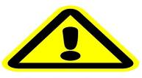

Riding Safety
- This e-bike can be exposed to light rain and snow, but cannot wade into water. Submerging the motor hub will cause the bike to stop and may cause damage.
- Please do not exceed the maximum load, for example carrying passengers or heavy objects.
- Before you ride this eBike in a busy area or on public roads, practice riding in a safe area free from hazards. Take time to learn the eBike’s controls and power.
- On the road, never undertake a vehicle as it may not see you, and turn left into your path. Please pay particular attention to busses and large vehicles, as it is difficult for raised cabins to see cyclists.
- Turn off the power using the key when stopped, to conserve power.
- Users should observe local road and traffic regulations for standard bicycles in force in the country of use at all times. It is your responsibility to identify and follow all local laws and regulations, including fitting your eBike with any additional equipment necessary to comply with local laws.
- Observe the applicable traffic regulations.
- At night your eBike MUST have a white front light lit. It MUST also be fitted with a red rear reflector, white front reflector and amber pedal reflectors which are both supplied.
- Never ride with no hands
- Do not wash your eBike with the battery charger connected to the battery whilst charging to prevent the possibility of electric shocks. Do not submerge the battery in water.
8. When pushing the bike, remember to always turn off the power switch.
9. All e-bikes should only be stored indoors.
10. Do not tamper with the electrical control unit on your eBike. This could endanger the rider.
11. Always wear a cycle helmet that confirms to current regulations for your safety to reduce the likelihood of head injuries.
12. Always pull the brakes and hold the handlebar firm and straight before taking off in order to make sure you keep control of the bike when power assistance is in action. Note that power assistance is triggered off immediately as soon as your foot slightly presses on the pedal.
13. This eBike is intended for use as a commuter and leisure bicycle. Using the eBike for any other purpose may result in serious injury.
14. Adopt a speed that reflects the terrain as well as your riding ability.
15. Use designated cycle paths when not using public roads.
16. When riding your eBike, wear close-fitting trousers, or use a bicycle clip. Loose clothing can get between moving parts and cause injury.
17. Wear bright and/or reflective clothing when cycling.
18. Your eBike saddle should be as close as possible to horizontal. Do not tilt the saddle backwards, as this can lead to back pain and physical injury.
19. Take care when loading your eBike into a car or when mounting it on a bicycle carrier.
20. We DO NOT recommend that you use a bicycle trailer with your Zipper eBike.
21. You can fit a standard fitment luggage carrier to your eBike.
22. We DO NOT recommend that you use a child seat with your Zipper eBike.
eBike Safety
1. You must be over 14 to ride an eBike.
2. The drive assist system is limited to a maximum continuous power rating of 0,25kW (250W) and a maximum speed of 25Km/h, (15.5 mph).
3. Your eBike is designed for a maximum permitted overall weight (rider + luggage + bicycle) of 110kg. The permissible total weight of the rider plus luggage is 90kg.
4. Do not submerge your eBike in water.
5. Be aware that the speed at which you are travelling may be faster than you are used to, especially when accelerating.
Braking Safety

1. Loosen the throttle and use the brake only; apply the back brake first by pulling the left hand brake lever and then the front brake by pulling the right hand lever. If you need to brake urgently, please use both the front and back brake at the same time.

2. Regularly check your brakes for signs of wear and tear. Any worn parts must be repaired or replaced immediately.

3. Be careful while getting used to the brakes. Practice emergency stops in a place clear of traffic until you are comfortable controlling your eBike.

4. Wet weather reduces your braking power and the grip of the brakes. Reduce your speed and be aware of longer stopping distances when cycling in wet conditions.

5. Braking on unpaved surfaces will differ. Be sure to practice braking on different surface types.

6. Ensure that braking surfaces and brake pads are free of wax, grease and oil.

7. Do not pedal and brake at the same time as this will cause excessive wear.

Electrical Safety

Charger Safety

1. Do not use the charger in places of heat, excessive smoke and dust, moisture and direct sunlight.

2. When charging, please keep the charger in a well ventilated room and on a flat surface.

3. Do not allow any liquid near the charger and do not insert any metal items.

4. Do not drop, impact or try to dismantle the charger.

5. Do not attempt to repair a broken charger yourself, charger replacements are available to purchase.

6. Do not leave a battery charging unattended, charging should be done while supervised and away from valuables, pets, children and flammable items.

7. Unplug the charger when not in use.

8. The charger should only be cleaned with a dry cloth. Never use a wet cloth, oil or any other liquid.

9. Do not use an extension cable. An extension cable if not 100% compatible might catch fire or cause an electric shock.

10. Before use, check the charger cord for signs of damage or ageing. A damaged or entangled charger cord increases the risk of fire and electric shock.

11. Do not abuse the charger cord. Never carry the charger by the cord.

12. Do not pull the cord to disconnect from a socket; grasp the plug and pull to disconnect.

13. Don’t wrap the cord around the charger when storing.

14. Keep the charger cord away from hot surfaces and sharp edges.

15. Do not handle the charger with wet hands.

16. The charger must be removed from the socket before removing the battery, cleaning or maintaining the appliance.

Power Display

Your Zipper bike has a built in battery indicator on the handlebars, when the battery is full all five LEDs should light, and when the indicator shows only two LEDS lit then the battery needs to be charged. Sometimes the lights may flicker or turn off and on which is normal.

Charging Procedure

- Only use the supplied charger and battery, and double check to make sure the output of your charger matches your battery. Any other battery is not compatible and risks exploding while charging causing serious injury to people as well as damage to other equipment. Using your charger to charge batteries not supplied by Zipper Bikes could risk catching fire, provoke electric shock and/or cause serious injury.

2. When charging, connect the battery to the charger first and then plug the charger into the mains.

3. When charging, the power indicator light is red to indicate the battery is still charging. When the battery is fully charged (3-6 hours), the charging indicator lights will change from red to blue or green, and the charger should be unplugged soon after. Charging time should generally never exceed 8 hours. IMPORTANT - NEVER LEAVE A BATTERY CHARGING OVERNIGHT UNATTENDED.

4. After charging, you should pull the charger plug out of the mains and then disconnect the battery from the charger. If you only wish to partially charge the battery for storage charging time should be reduced accordingly.

5. If you smell burning during the charging process of the battery or the charger gets very hot please immediately stop charging, and contact our customer service department or your local dealer for advice.

Battery Safety

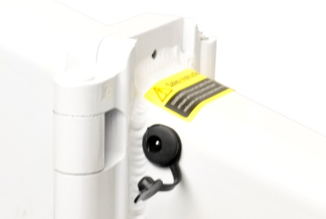
This eBike comes with a built-in battery, to ensure that the power will not cut out unexpectedly. Please read the following page on maintenance carefully.

- Please fully charge the battery before first use as described above.

- Please only use the supplied or designated chargers. Otherwise damage may occur to the battery and other related accessories, which could result in an accident. Any damage, loss or fault arising from incorrect charging procedure or from using the wrong charger will be borne by the purchaser.

- The battery can be charged while inside the bike. Some models can also be removed from the bike for charging. The battery will need using (cycled) around 8-10 times before it reaches optimum performance and capacity.

- Be careful that the metal ports at the end of the battery box or connecting leads do not touch any other metal as this can cause a short circuit, particular attention should be made with folding bikes.

- Do not drop, impact or try to dismantle the battery.

- Do not use the battery for long periods of time under sun exposure or hot temperatures. If you don’t use your electric bike for a long period of time, please charge it every two months, charging to half capacity is considered efficient.

- Ensure water does not enter the batteries charging port and that the battery is never exposed to humidity.

- When discarding unwanted batteries, first discharge the battery to zero voltage. Never put into a fire!

- This bike includes Li-Ion batteries. Keep away from children, liquid, heat or fire. Do not incinerate.

- When you dispose of the appliance remove the battery and dispose of the battery safely in accordance with local regulations.

- You must always use the battery in accordance with the instructions on the battery label.

- Liquid ejected from the battery may cause irritation or burns.

- Leaks from the battery cells can occur under extreme conditions. Do not touch any liquid that leaks from the battery. If the liquid gets on the skin wash immediately with soap and water. If the liquid gets into the eyes, flush them immediately with clean water for a minimum of 10 minutes and seek medical attention. Wear gloves to handle the battery and dispose of immediately in accordance with local regulations.

Mechanical Parts Safety

1. Fastening components:
1.1. The handlebar, head tube and saddle tube must be locked with 18Nm torque.
1.2. Locking force of 15-17 KGF is required on quick disassembly parts.
1.3. The front wheel nut locking torque needs to reach 18Nm, and the rear needs to reach 30Nm.

- Lubrication: The chain, flywheel and headsets need regular maintenance. Drop a little oil onto the chain, and apply drops every month.

- Adjust the rear ends of the chain. Loosen the nut, adjust the rear wheels front and rear position as needed to achieve the chains proper tightness, the middle position of the chain if pushed down with your finger should only drop 10-15mm.
- Pay attention to the front and rear brake blocks, if worn they should be promptly replaced, to avoid loss of braking and wearing the aluminium ring.

User Guide

Folding Lock Mechanism

Ensure the latch is firmly locked in place before riding. The latch should lie flat against the frame when in the locked position. CAUTION – Be careful not to trap your fingers in the frame when unfolding and locking the mechanism to avoid injury.

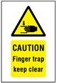
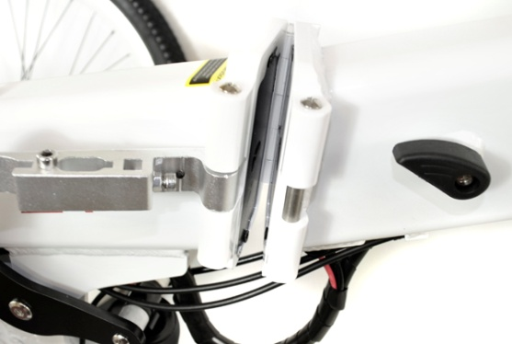
Rear Wheel Lock

Located at the back of the bike is the wheel disabler, this has been designed to prevent the wheel from moving when locked, which will foil people who attempt to steal the e-bike.

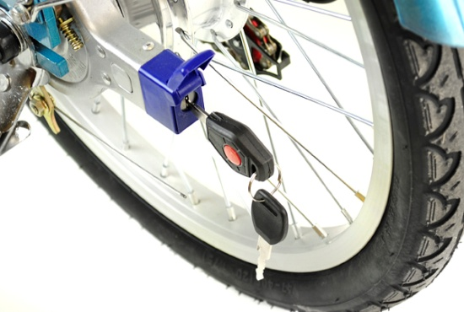
Assembling Your E-Bike

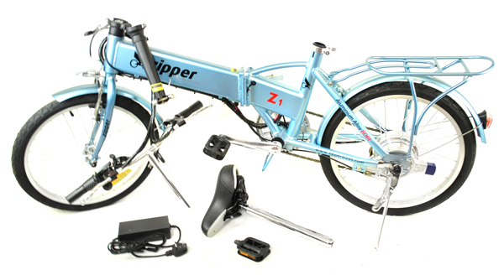

Adjusting The Front Braking System

The right brake lever activates your front brakes. Check the right hand braking handle as shown below, there should be full front brake pressure when the lever is pressed halfway. If the clearance spacing is different on the left and right pads, you can adjust the adjusting screws on each brake arm until the distance of the two clearances are the same. Loosen the spring tension adjusting screw, then tighten or loosen the brake cable to make the clearances between the brake pad and the wheel rim to be approximately 1.5-2mm. Tighten the tension screw when the clearances of the right-hand-side and left-hand-side pads are equal.

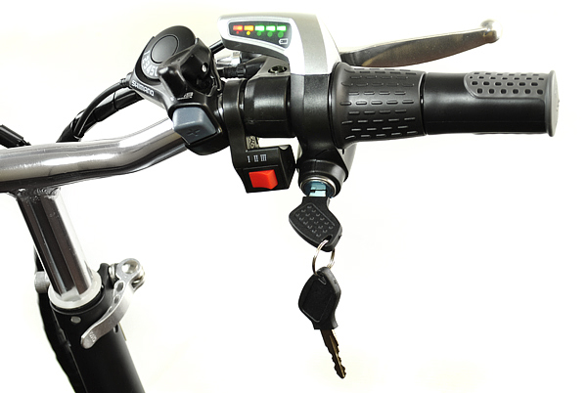

Adjusting The Rear Braking System

The left brake lever activates your rear brakes. Check the left brake lever the same way as checking the right brake lever but on the rear brake, adjusting the adjustment screw as needed. If this does not work, loosen the nut of the brake cable anchor bolt, then loosen or tighten the cable until the proper tension is reached. If this still does not work, you can adjust the clearance fine adjustment screw, and keep the clearance of the internal brake pad the same. Adjust these parts until the rear brake works correctly.

Adjusting The Front V-Brake Pad
Adjust one side first and then adjust the other. Please make sure the clearances between the brake pad and the wheel rim is approximately the same on both sides, the optimal clearance width is around 1.5mm. Tighten the nut after you have finished adjusting.

Emergency Braking

When emergency braking, your weight will shift forwards, reducing the load on your rear wheel. This can cause your rear wheel to slip, which is dangerous, especially when riding downhill. When emergency braking, keep your weight back and as far down as possible. Brake smoothly and remember your front brake will take more load when braking harder.

Installing The Front Wheel

Rest the front fork on the hub axle. Use the included washers and nuts to tighten the wheel to the bike. Please note the unique shape of the washers, the latch must be inserted into the hole on the fork, before tightening. When tightening the latch it should lie flat against the fork when in the closed locked position. If you replace the wheels, please tighten the nuts according to the recommended torque; the rear wheel torque should be no less than 30Nm while the front wheel torque should be no less than 18Nm.

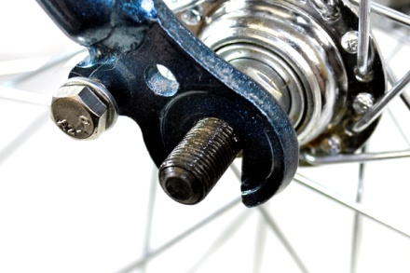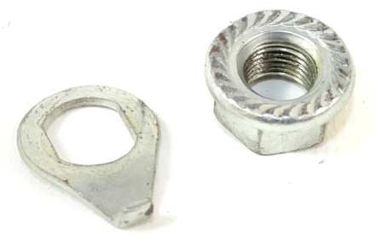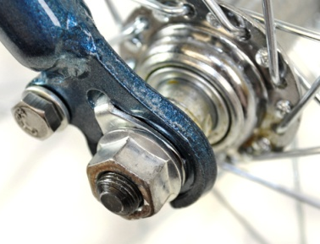

Inflating The Tyres

1. Remove the valve cap.

2. Briefly press down on the valve to make sure the valve doesn’t stick and to remove any loose dirt.

3. Press the pump nozzle onto the tyre valve stem as far as it will go.

4. Lift the thumb lock lever into the locked position.

5. Pull out the end of the bicycle pump and push down to start inflating the tyre, continue to do this until you have reached the desired tyre pressure. Do not inflate beyond the maximum tyre pressure – printed on the sidewall of the tyre.

6. Release the thumb lock by pushing the lever back down.

7. Remove pump nozzle from the valve stem.

8. Replace the dust cap.

Installing the Handlebars

First lock the folding handlebar tube in place. The quick release lever should lie flat against the handlebar stem when in the closed locked position. Next insert the steering tube of the handlebars, stand in front of the e-bike and keep the front wheel between your legs, hold the handle bar with both hands tightly, and then adjust the handle bar angle preferably so that the handles are at a right-angle with the handlebar tube, the height of the handlebars should be adjusted to your personal size and preference. Please do not extend the handlebar height over the maximum limit warning line or you may cause injury. Once the angle and height are correct be sure to correctly tighten the nut at the top of the handlebar tube and close the latch firmly. The latch should lie flat against the handlebar tube when in the closed locked position. CAUTION – Be careful not to trap your fingers when locking the quick release mechanism and unfolding the handlebars.

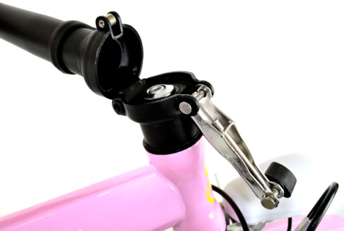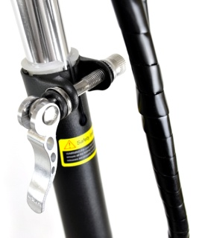
Installing the Seat/Saddle

Insert the seat post and adjust the seat height as follows:

1. Sit on the bike saddle.

2. Try to reach the pedal with your heel when it is in the bottom position. Your knee should be more or less fully straight.

3. Place the balls of your feet on the centre of the pedal. If your knee is now slightly bent, the saddle height is correct.

4. Never adjust the saddle so the minimum mark (marked on the seat post) is above the top of the seat tube, otherwise you could injure yourself or damage the seat post! Firmly tighten the seat post clamp with the quick release lock so that it lies flat against the frame.

5. Check that the saddle cannot move once the quick-release is closed. If it does move, tighten the adjusting nut, until you need to use the palm of your hand to close the quick-release lever. CAUTION – Be careful not to trap your fingers when locking the quick release mechanism.

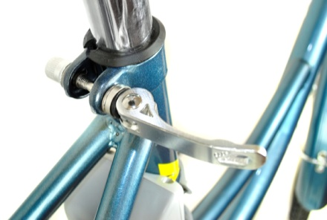

Adjusting The Chain
Release the rear hub nut and adjust the position of the hub to adjust the chain tension (the chain slack should be 10~15mm), align the chain wheel with the rear sprocket so that they are in the same straight line, and then tighten the rear hub nut. Rotate the crank set counter-clockwise, the chain should have the appropriate tension and run smoothly. CAUTION – Keep loose clothing away from the chain when riding as it may become tangled and cause injury.

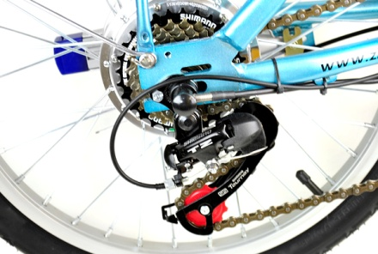

Installing The Pedals

Normally the pedals are marked with an “L” for left or an “R” for right, if they are not marked then they can be used on either side. Please install accordingly, otherwise the crank arm can be damaged.

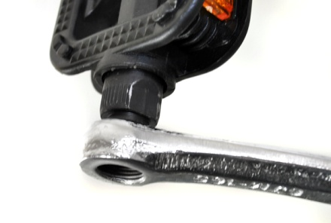

Installing The Front Mudguard

The headlamp comes pre-installed, however to attach the mudguard this must be loosened. Remove the nut on the back of the head tube, pass the mudguard over the tyre and hook the latch onto the bolt, then retighten the nut, both the headlamp and mudguard should now be in place. The mudguard spokes attach to the front fork, and are tightened into place by using the included washer and bolts onto the front wheel hub.

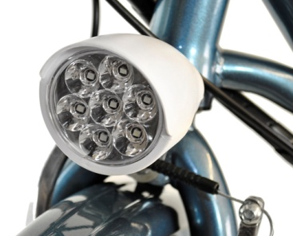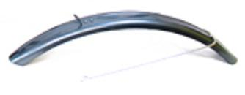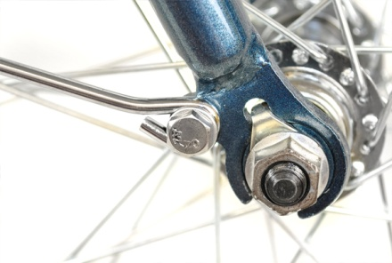

Adjusting & Operating The Gears

Your eBike comes fitted with a Shimano gearbox. Please see the included Shimano manual for adjustment and operation instructions.
Light Operation

Your eBike comes fitted with an LED night light. The night light must always be turned on when riding in the dark. To turn the light on press the light button on the left handlebar. To turn off the light press the button again. Be sure to regularly check that the LEDs are working and replace as needed. Replacement LEDs are available from www.scootercity.co.uk.
Cleaning
Clean using a soft bristled brush to remove dirt and then washing with warm water. Do not apply water directly to rear drum brake, motor and hubs to avoid performance drop or shortening of life expectancy. Do not use steam, a hose pipe or high-pressure water gun to clean. Do not wash your eBike with the battery charger connected to the battery whilst charging to prevent the possibility of electric shocks. Do not submerge the battery in water or use to much water near the battery. After cleaning, dry your bike using a soft cloth.
Maintenance
WARNING:
As with all mechanical components, the bicycle is subjected to wear and high stresses. Different materials and components may react to wear and tear or stress fatigue in different ways. If the design life of a component has been exceeded, it may suddenly fail, possibly causing injuries to the rider. Any form of crack, scratches, or change of colouring in highly stressed areas indicate that the life of the component has been reached and it should be replaced.
For composite components, impact damage may be invisible to the user, the manufacturer shall explain the consequences of impact damage and that in the event of an impact, composite components should either be returned to the manufacturer for inspection or destroyed and replaced.
1. After an accident or crash you must take your eBike to a bike repair specialist to make sure that it is safe to ride. Be aware that damage may not be visible. Failure to do this may result in serious injury.
2. Any form of crack, scratches or change of colouring in highly stressed areas indicate that the life expectancy of the part has been reached and it should be replaced immediately.
3. Ensure the battery is removed from the bike before carrying out any maintenance.
4. Make sure that all screws and bolts are tightened securely and to the prescribed tightening torques before riding.
5. You must always use genuine replacement parts when performing maintenance on your eBike.
6. Regularly check the tyre pressures (minimum 50psi, maximum 75psi) and regularly check the tread depth of tyres.
7. Regularly check the brakes for wear and adjust or replace them if needed.
8. Check the wheels for buckles or damaged spokes and have them repaired immediately by a qualified bike repair specialist.
9. Regularly check your light to ensure the LEDs are working and replace if needed.
10. Check your wheels rims for wear. Each time the brake pads come into contact with the rim’s braking surface, a little rim material is abraded away. After a while, the rim will have a concave channel cut into it from the brake pads. When rims get this worn, i.e., this far past their intended life, there is very little structural material remaining to hold the rim together. This could be very dangerous as the wheel could crack while in use causing serious injury. Visually inspect your braking surfaces for excess wear. Usually this manifests itself as a concave profile on the rim. The easiest way to see this is by placing a straight edge (e.g. a metal ruler) across the rim surface. You'll see a significant area of daylight between the rim and the ruler if wear is excessive. Also look for grooving running around the rim, often caused by grit lodged in the brake blocks. These grooves can be the first places that the rim can fail. If the rims show signs of rim wear they must be replaced.

Maintenance Schedule | Daily | 60 Days | 180 Days
1.1 Before each ride, check whether tyre pressure is appropriate. Normally, the pressure is 125KPa for front wheel and 175KPa for the rear wheel.  1.2 Any cracking or abnormal wear on the tyres or rims.  1.3 Any nails, stones or glass stuck inside the tyres. |  | / | /
2. Brakes work normally? |  | ❐ | ❐
3. Any damage on the charger and power cable?
4. Front and rear hub nut tightened? Throttle and turning mechanism parts loose or worn? |  | / | /
5. Brake pads worn? |  | ❐ | ❐
6. For folding E-Bikes, check locking mechanism is secured.
7. Chain drive mechanism. |  | ⬧ | ⬧
8. Crank arm worn out? Smooth rotation? |  | / | /
9. Wheel spokes loose or broken? |  | / | /

= Check  = Adjust/Replace  = Lubricating

Replacement parts for worn components such as tyres, tubes and brake friction parts are available from www.Scootercity.co.uk. For safety it is important to use only genuine replacement parts for safety-critical components.

Troubleshooting

Problem | No. | Analysis | Solution
No power after turning the power key including no lights etc | 1 | Electric lock is damaged | Replace multifunction throttle
 | 2 | Line conductor is broken | Repair or replace line
 | 3 | Battery problem | Check battery with voltmeter and ensure battery is charged. If no power from battery replace.
No motor power after turning the key but lights etc are still working. | 1 | Battery under voltage protection level | Charge the battery
 | 2 | Throttle is broken/line conductor is abnormal | Replace throttle / repair line conductor
 | 3 | Right and left brake is broken | Replace right and left brake
 | 4 | Controller and motor is broken or line conductor is abnormal | Replace controller and motor, maintain the line conductor
Range is low | 1 | Battery voltage is too low/not charged enough. | Charge the battery fully until charger lights turn blue or green. If still a problem battery has been charged incorrectly and needs replacing.
 | 2 | Tyre pressure is not enough | Blow up the tyres
 | 3 | When braking, uninterrupted power | Replace the brake, maintain the line conductor
 | 4 | Mechanical parts turn badly and  Cause resistance | Maintain the bad parts, replace the fault worn parts
 | 5 | More uphill, drive against wind, frequent braking, overloading | Correct bad drive mode, read our best driving practices guide.
 | 6 | Battery is too old and broken | Replace with the same model battery
Power indicator light displays normal but when driven with assistance the motor supplies no power | 1 | Pedal position the PAS assistance is off normal | Adjust the PAS assistance, have no deviation and loosening phenomenon
Charging the battery shows abnormal, the charger’s indicator light is flashing, and the battery can’t be charged | 1 | Charger into state of burst discharge | Check battery charge loop if it has short circuit phenomenon
 | 2 | Charger is broken | Replace with a new model charger that is the same
 | 3 | Charger is not connected, socket is damaged | Reconnect the charger with new socket

